# Optimisation Report

## HTML

### Web Page Analyzer

[Web Page Analyzer](http://www.websiteoptimization.com/services/analyze/) can be used to calculate the page size, composition, download time, size of individual elements and then sums up each type of web page component. It can also provide information and advice on how to improve/optimise the page load time.

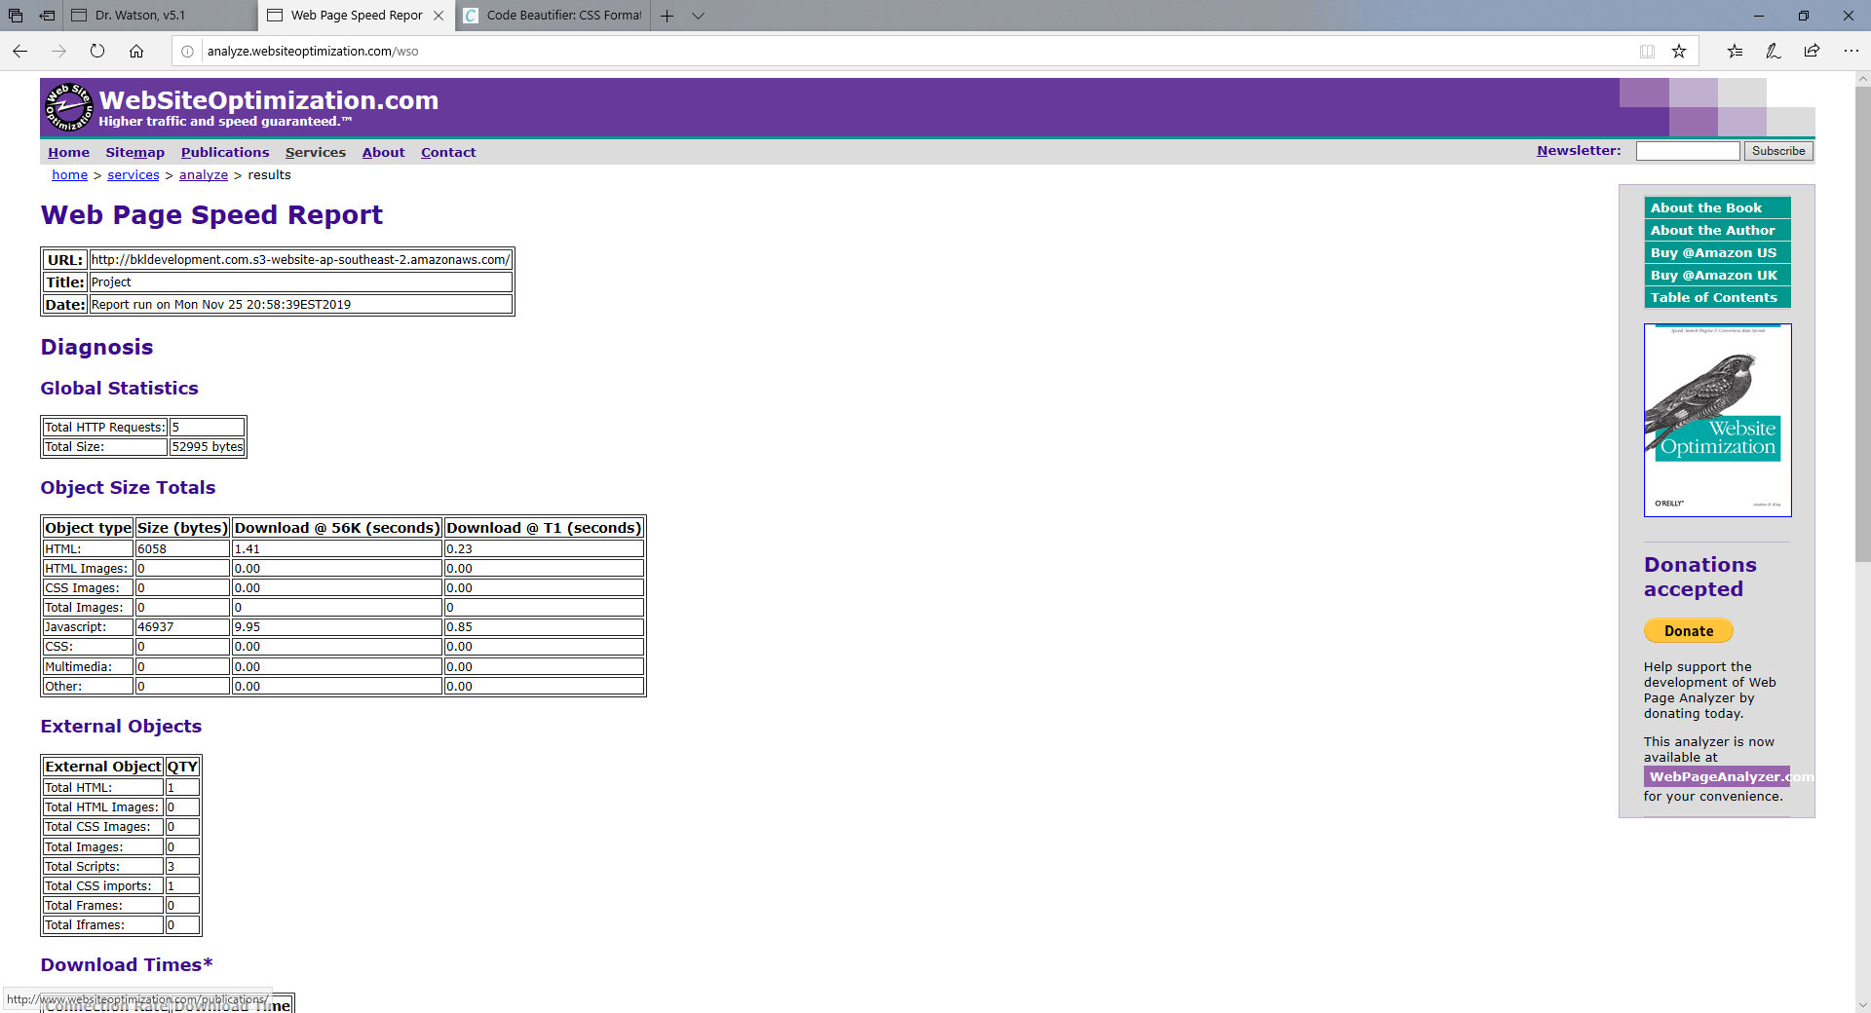

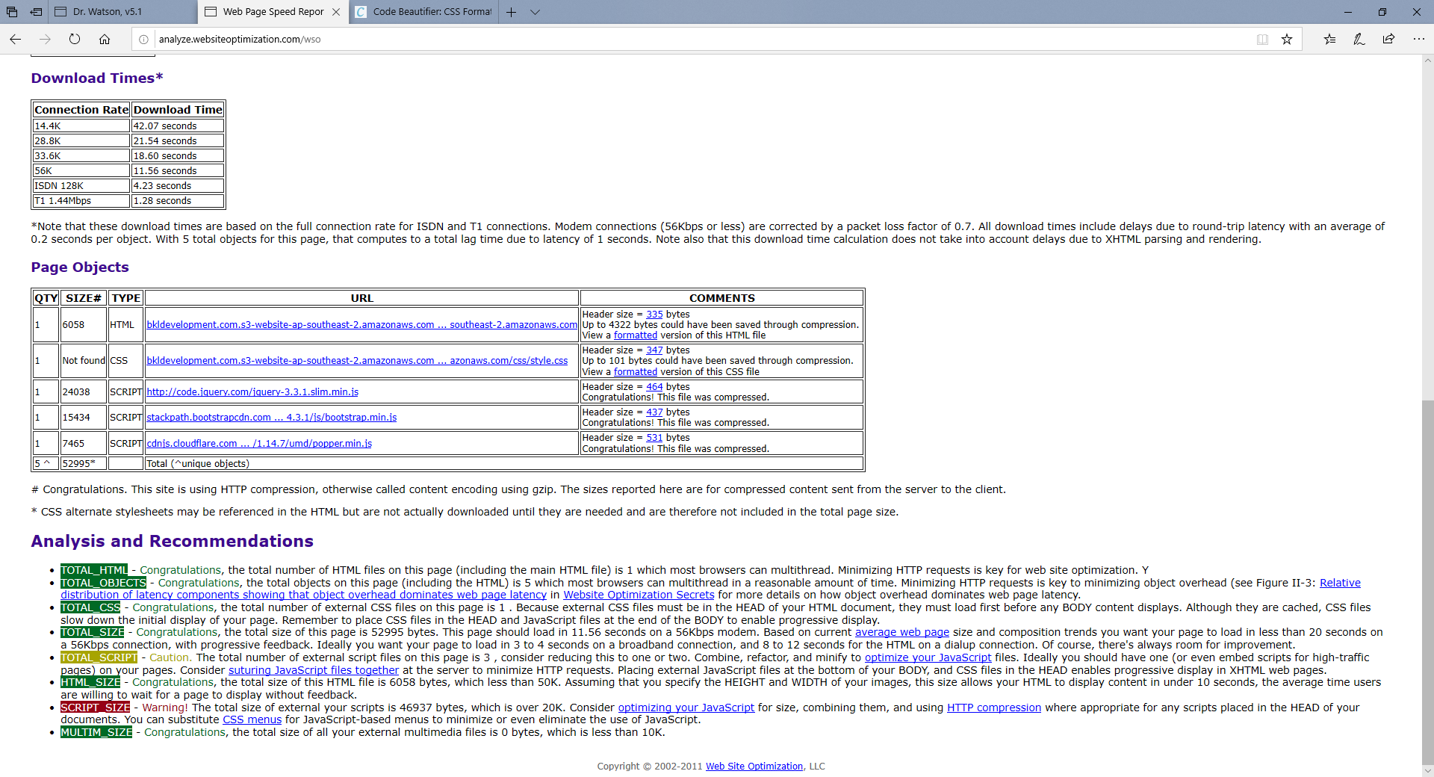

### HTML Code Beautifier

[HTML Code Beautifier](https://www.tools4noobs.com/online_tools/beautify_html/) is a HTML optimisation tool that cleans up and formats HTML code for the purpose of readability and format control. The HTML code beautifier can receive direct code snippets, or a live web address and will output the beautified code in a copiable output box.

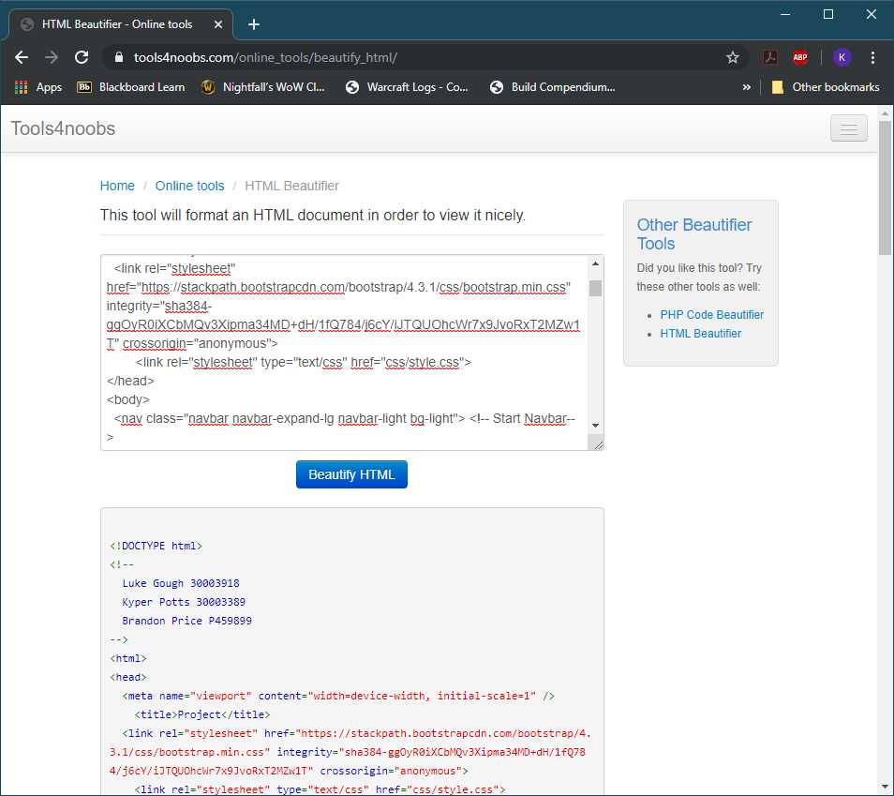

## CSS

### Code Beautifier

[Code Beautifer](http://www.codebeautifier.com/) is a CSS optimisation tool which can be used to clean the chosen CSS file. It has multiple options which the user can select from and allows you to insert your CSS code via a link or direct upload.

The code beautifier made the following changes to the CSS code

1. Optimised color: Changed "white" to "#FFF"
2. Optimised number: Changed "0px" to "0"
3. Invalid property in CSS2.1: border-radius
4. Fixed invalid color name: Changed "lightblue" to "#ADD8E6"
5. Optimised color: Changed "white" to "#FFF"
6. Optimised color: Changed "black" to "#000"

## PHP

### PHP Code Beautifier

[PHP Code Beautifier](https://www.tools4noobs.com/online_tools/beautify_php/) can be used to format PHP code so it can be viewed nicely.

The code is uploaded into a text box and then submitted to the beautifier, it then generates the beautified php code in a read only text box which can then be copied and used to replace the original code written.

